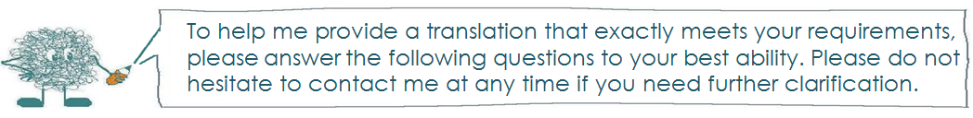

- Who is the contact and buyer of the translation?

Name and job title:
Direct telephone line:
Email address:
Company name:
VAT number:
Website:
Fax number:
Contact address: |  | Billing address:  (if different from contact address)
Client’s project name:
Requested deadline:
(Below to be filled in by Translator)
Project no: |  | Task:
File(s):
Word count/hours: |  | Price:
Agreed dead line: |  | Quote:

- What are the intended purpose and the intended target audience for the translation?

- Who will make use of the translation and in what way?
- Is the tone of the text intended to be informal or formal, and is there any other specific requests regarding language and style?
- What will the translation look like in its final layout? If required, is there space in the layout for more text?

- Can you supply any reference material?

- Website or links:
- Glossaries of specialized terms used in your particular field/company.
- Translation memory files if you use the CAT software Trados.
- Previous translations done for you or your company on a similar subject.

- Does the text contain any unexplained acronyms? If so, please give details below and place a cross under the appropriate heading to instruct me how they should be dealt with in the target text.

Acronym | The letters stand for the following words: | Translate to the target language equivalent | Include as shown in the source text only | Include a translation/ clarification in brackets | Include the original acronym in brackets

- Are there any numbers (e.g. currencies, measurements etc.) which need to be included in the target text? If so, I would normally include these in the same format as provided by you. Please confirm if this is acceptable or advise if you have any other requirements.

- Are there any pictures or tables in the text that you would like for me to translate? If so, I would normally insert the translation underneath the picture within brackets, or insert it as a comment. Please confirm if this is acceptable or advise if you have any other requirements.

- Are there any specific instructions regarding names?

Please place a cross in the appropriate boxes | Translate | Do not translate | Include a translation/ clarification in brackets | Include the original name in brackets
General job titles

Specific job titles

Company & product names
People’s names and place names
Names of magazines, publications etc.
Other
(please write in full)

- Are there any further instructions regarding what to translate and what to leave in the source language?

- Other instructions or comments

Thank you for taking the time to fill in this order form.
I will get started on the translation as soon as I have received you approval of the quote and delivery date.

Kind regards,


